DESIGN AND ANALYSIS OF ALGORITHM

SESSION-1

LAB EXPERIMENTS

NAME: S.PRITHISH

REG NO:192421134

1: First Palindromic String in an Array and find its complexity
sol:n = int(input("Enter number of strings: "))

arr = []

for i in range(n):
arr.append(input("Enter string: "))

for s in arr:
if s == s[::-1]:
print("First Palindromic String:", s)
break
else:
print("No Palindromic String Found")
OUTPUT:
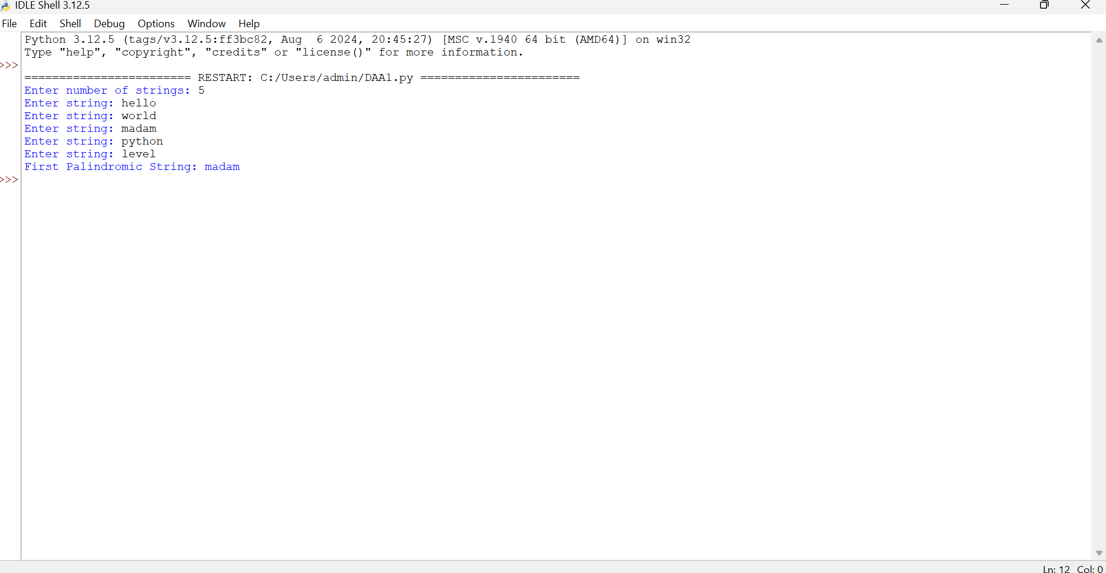

2: Common Elements Between Two Arrays and find its complexity
SOL:n1 = int(input("Enter size of first array: "))
a = []

for i in range(n1):
a.append(int(input("Enter element: ")))

n2 = int(input("Enter size of second array: "))
b = []

for i in range(n2):
b.append(int(input("Enter element: ")))

common = []

for i in a:
if i in b and i not in common:
common.append(i)

print("Common Elements:", common)
OUTPUT:
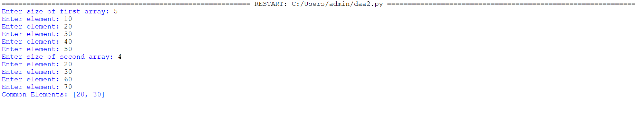

3: Subarrays Distinct Element Sum of Squares
SOL:n = int(input("Enter size of array: "))
arr = []

for i in range(n):
arr.append(int(input("Enter element: ")))

total = 0

for i in range(n):
distinct = set()

for j in range(i, n):
distinct.add(arr[j])
total += len(distinct) ** 2

print("Sum of Squares:", total)
OUTPUT: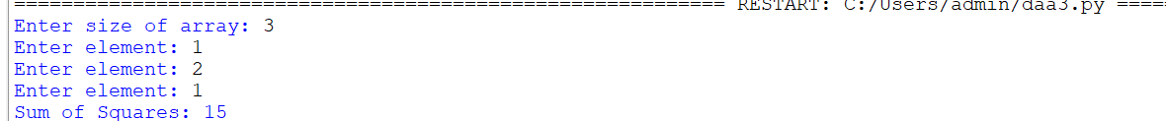

4: Count Equal and Divisible Pairs in an Array
SOL:n = int(input("Enter size of array: "))
arr = []

for i in range(n):
arr.append(int(input("Enter element: ")))

count = 0

for i in range(n):
for j in range(i + 1, n):
if arr[i] == arr[j] and (i * j) % 2 == 0:
count += 1

print("Count of Equal and Divisible Pairs:", count)
OUTPUT: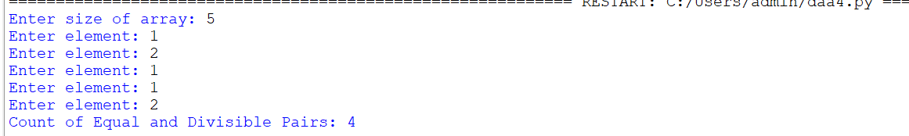

5: Maximum Element with Least Time Complexity
SOL:n = int(input("Enter size of array: "))
arr = []

for i in range(n):
arr.append(int(input("Enter element: ")))

maximum = arr[0]

for i in range(1, n):
if arr[i] > maximum:
maximum = arr[i]

print("Maximum Element:", maximum)
OUTPUT:
